Photo Essay

Lloyd Dominic G. Refuerzo

Nathaniel D. Villaluz

8 – Marignano

Topic: History (Philippine History)

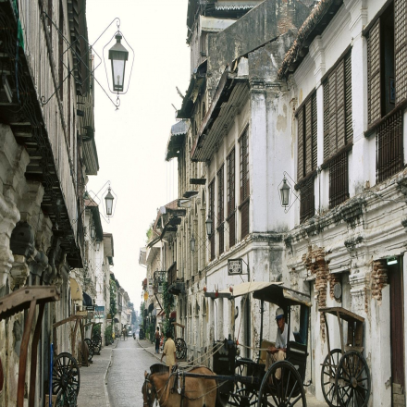

Spanish Colonization

The Philippines had been colonized a couple of years ago. This was, because a Portuguese explorer, Ferdinand Magellan, discovered the Philippines. The Filipinos were hardly suffering, at that time. But, they’re not only onto colonizing the country and gathering our country’s resources; they also left great influences for the Filipinos.



Katipunan

The *Katipunan*, or *Kataastaasan, Kagalanggalangang Katipunan ng mga Anak ng Bayan* was a Philippine revolutionary society, whose primary aim was to gain independence from Spain through revolution. It was headed by Andres Bonifacio, formerly known as “The Father of the Philippine Revolution”. The Katipunan was a secret organization, until its discovery in 1896 that led to the outbreak of the Philippine Revolution.